# PowerShell Lab 1 - KEY

Introduction to PowerShell

## Exercise

Pipe Get-ChildItem (ls or dir are aliases) into Get-Member (gm) and examine the methods and properties. Pipe Get-ChildItem into Export-Csv and open the resulting file in a spreadsheet, or pipe Get-ChildItem into Out-GridView. Examine the objects and their properties.

Note that there is one set of objects for directories and another for files.  
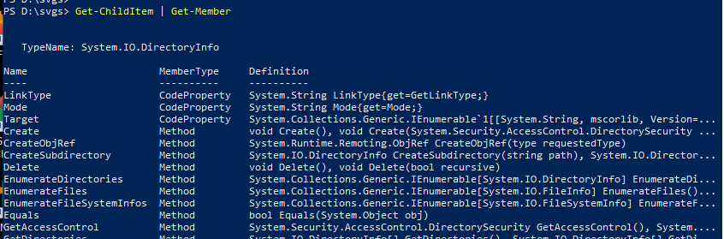  
<snip>  
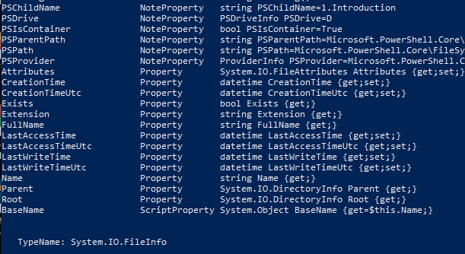  
<snip>  
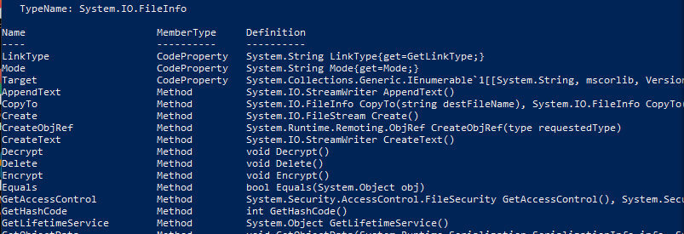  
<snip>  
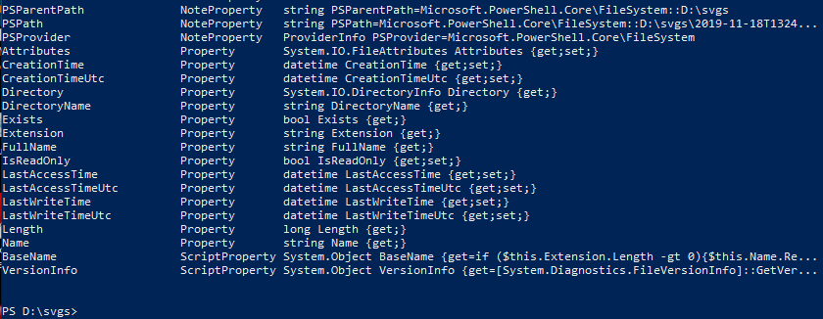

## Seeing the properties you want to see

ls | ft -Property Name, CreationTime, LastAccessTime, LastWritetime  
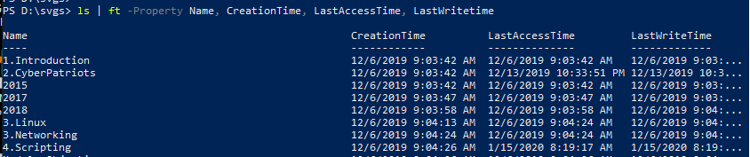

## Import-Csv

A nice thing about CSV files is that they save our data in a form that maintains the object format. You should already have files that save the output from Get-Process and Get-ChildItem. Use one of the commands below to move the data back into PowerShell’s memory.

$processObj = Import-Csv <filename you used to save Get_Process>  
or  
$dirObj = Import-Csv <filename you used to save Get-ChildItem>

Then look at the data with commands such as

$processObj.Path  
$processObj | ft -Property path  
or  
$dirObj.Name  
$dirObj | ft -Name

Saving the files now, didn’t save them before.  
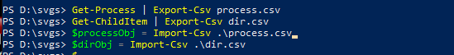

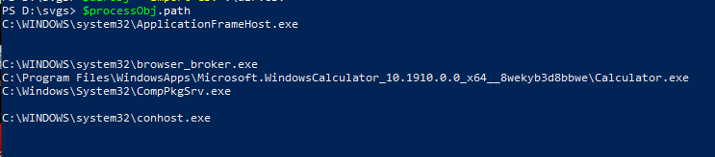  
<snip>

There are lots of process objects, so the output is long. The blank lines are for processes that don’t have anything in the Path property.

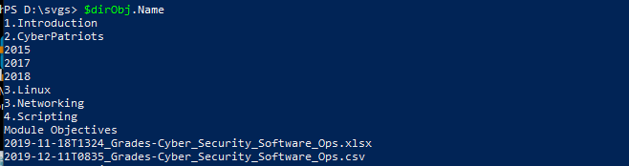

The point here is that the object structure and properties are intact.

Hand In  
Hand in the screenshots from items 1, 2, and 3 above.